Lockdown News from Springfield
We have been open every day so far with numbers of children ranging between 3 and 13.
During the first week the children in school worked together to create a giant rainbow which has been attached to the school gates and those in this week have added NHS stained glass patterns.
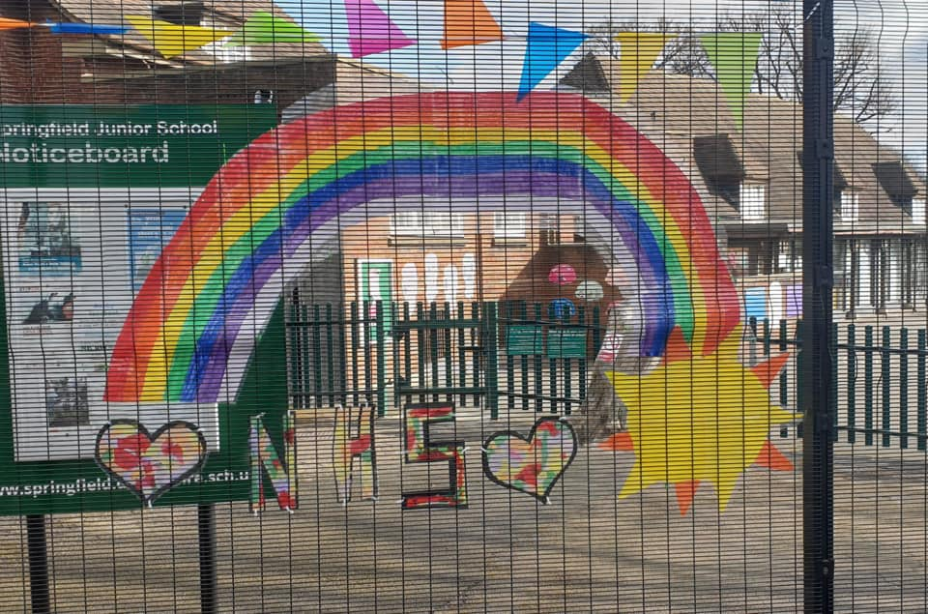

They went on a virtual trip to Chester Zoo on Friday 27th March and ventured into the Wildlife Area to look at the frogspawn on Monday 30th. They’ve been exercising daily and doing their Mathletics work on the laptops.

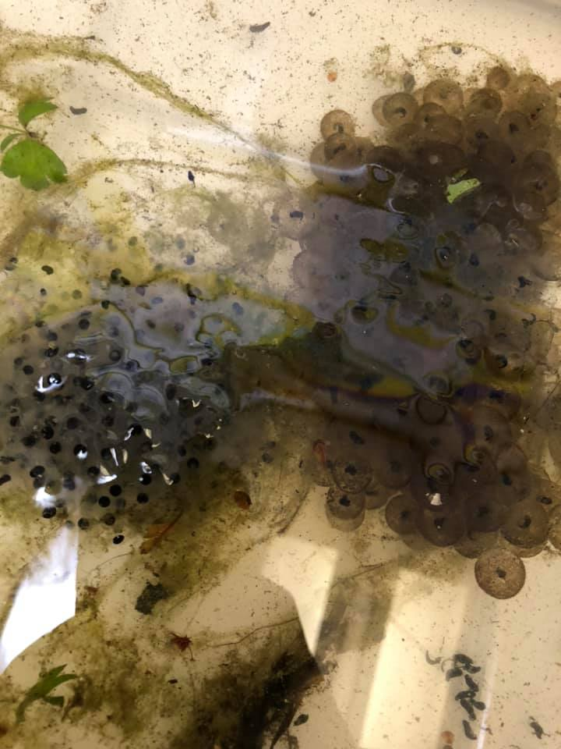
Mrs Haines and her Y3 class, Polar Bears have been communicating regularly for a few months with a teacher and children in a school in Cremona, Northern Italy which has been at the centre of the outbreak over there.
The children in Cremona sent pictures back to our children this week.
Mrs Haines posted this on Facebook:
These are the beautiful drawings I've just been sent from Italy from the children who some of the Y3s have been sending pictures and videos to.
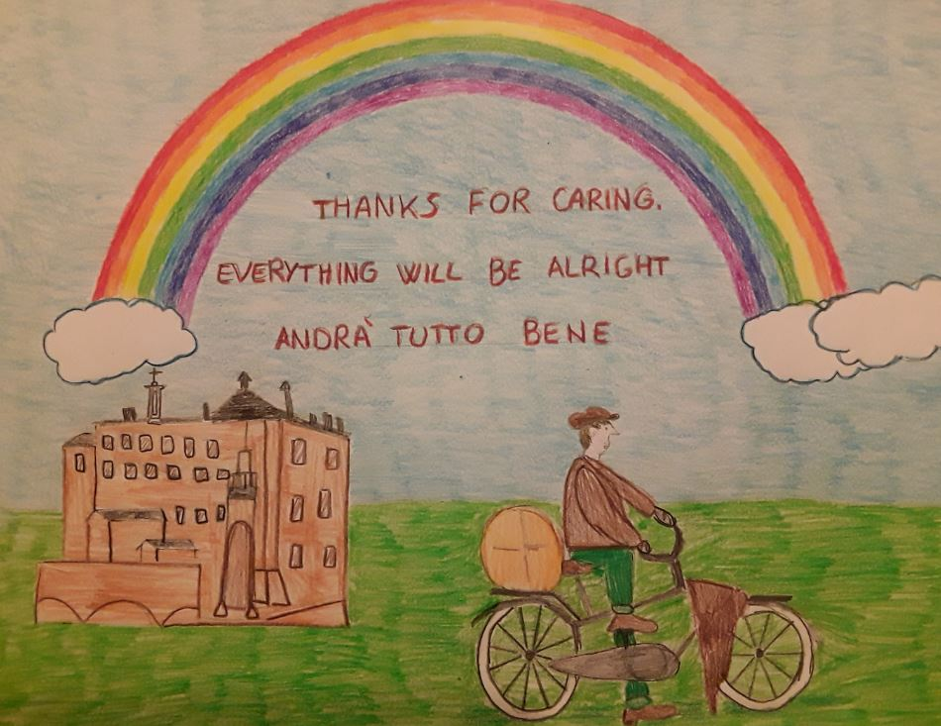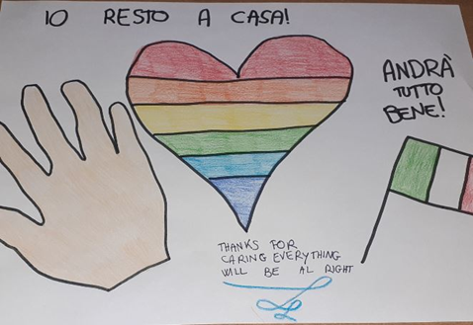
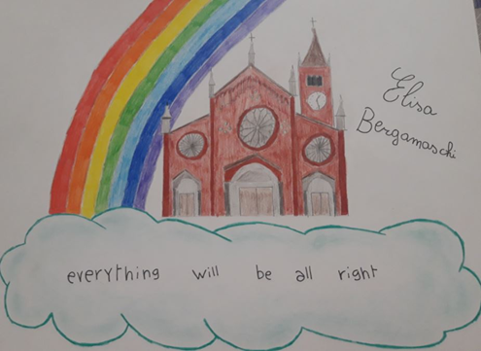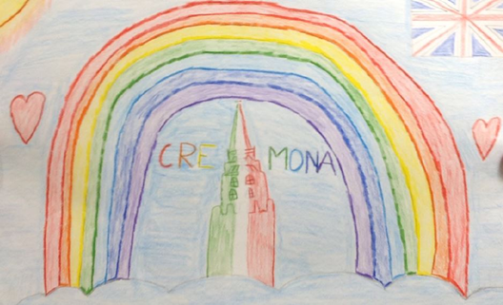
These children live in Cremona which is at the centre of the outbreak in Northern Italy. They have been off school for weeks now and their teacher says that we really cheered them up by showing we cared.
Mrs Haines
Some of the children at home saw the post to create pictures to decorate the Nightingale Hospital in London. Unfortunately, the request was a scam, but Mrs Haines contacted her friend who works at the Royal Derby and sent her Jess’s pictures which is now posted on the Royal Derby’s Intranet.
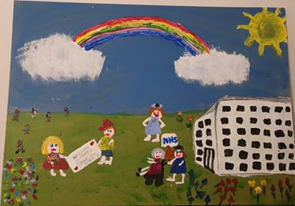
Others have been making Thank You posters for the NHS
This is a great one from the Birch household (Scarlett in Y6 and Keaton in Y4)
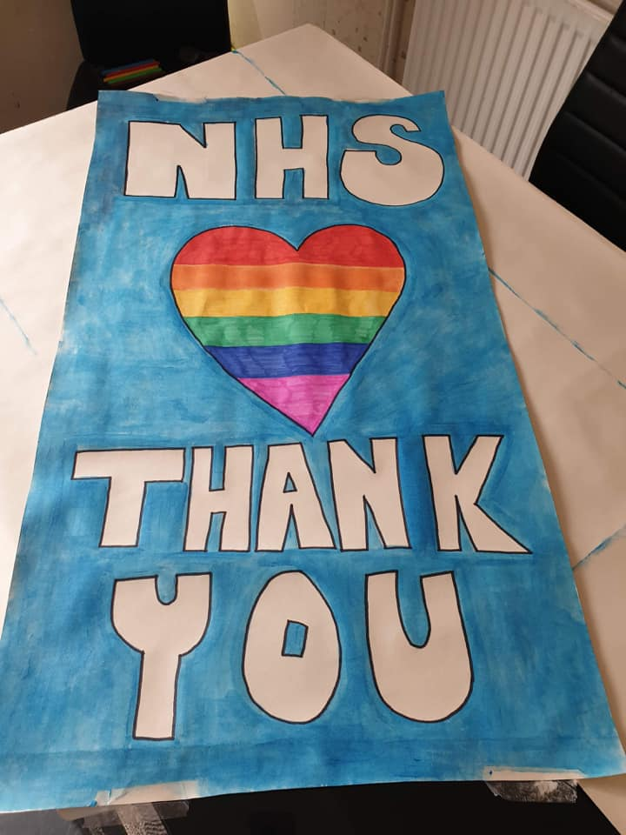
Lots of children have been engaging with their home learning and we’ve made phone calls to check up on those who didn’t appear to be engaging for one reason or another. A couple have had internet problems, so we’ve photocopied extra packs of work and posted it through letter boxes. There’s no escape!

Here are some examples of the things the children have been up to:
Y4 Orangutans
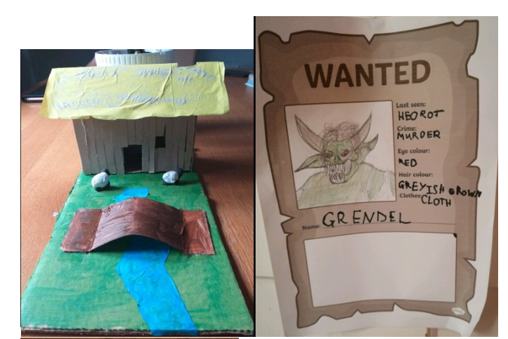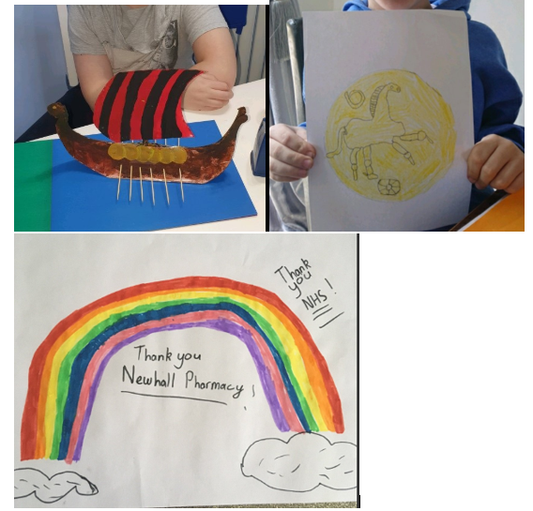
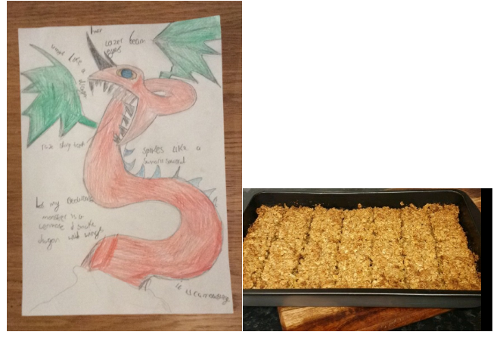

Y5 Penguins class have been on an adjective scavenger hunt today and found everything from a brain to a packet of Cheesy Wotsits!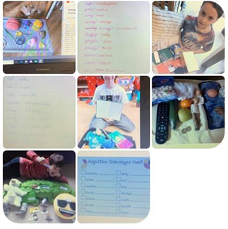
Sid has done some great writing whilst Murrey has been helping out at home.
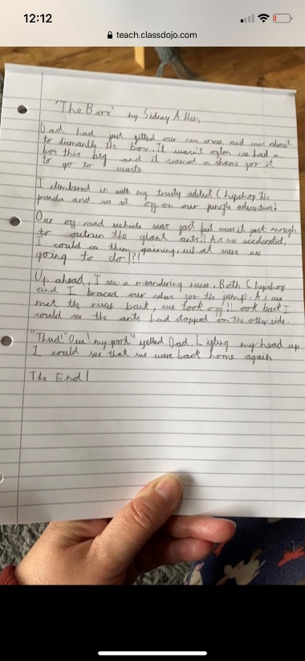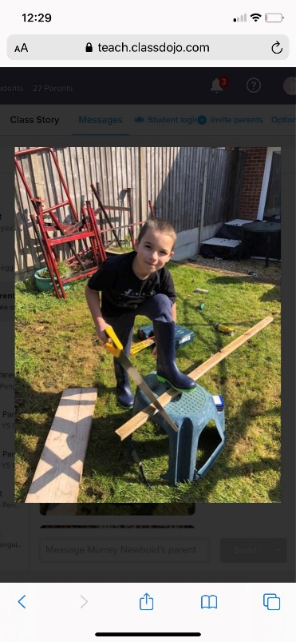

Below is a compilation of some of the things they got up to last week.
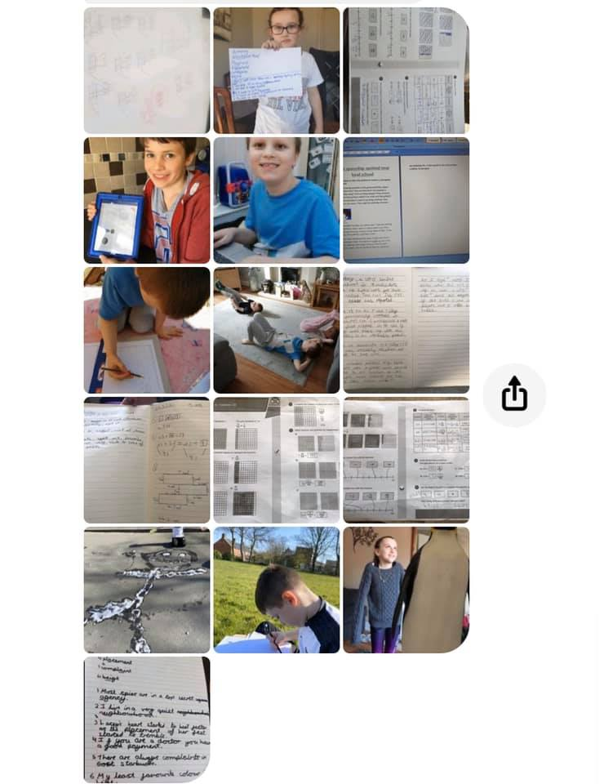
Year 6 have also been extremely busy and Amber in Y6 has made a game using Scratch!
Year 3’s busy working at home
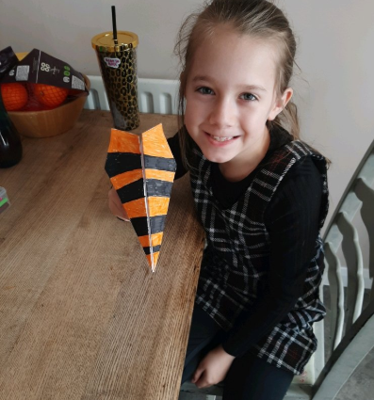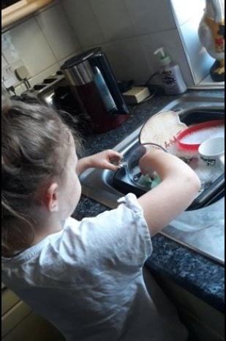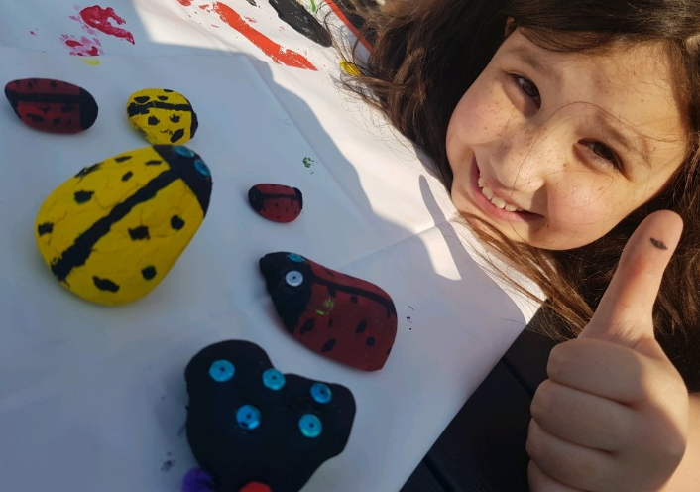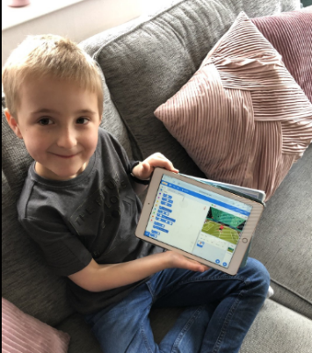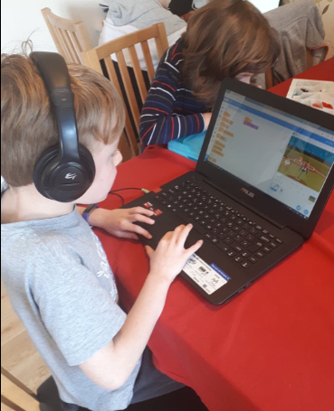

Children and teachers are officially on holiday for the 2-week Easter break although school will remain open with numbers ranging from 2 to 23. During that time, children in school will carry out holiday activities, sport and make things for Easter.
Hampers were distributed from the playground last Friday (3rd April) alongside food for Elmsleigh FSM pupils. 73 children received hampers (84 are eligible but 7 declined and 4 failed to turn up) so some of the extra food was given to families in greater need before taking the rest to the local refuge. Elmsleigh staff worked alongside us and the school cooks with the operation.
Elmsleigh staff will be in school along with around 6 pupils daily over the Easter break as we have been opening our doors and helping out whilst they have been closed.
We will be working hard at the start of the next week (w/c 6th April) to organise supermarket vouchers for pupils eligible for FSM.

