Document name | Tackling Extremism and Radicalisation  Non-Statutory
Document owner | Derbyshire Prevent team ( multi-agency steering group)
Authors | D. Peacock  CPM Schools/Education
Date approved | Seamus Carroll- senior Community Safety Officer, Safer Derbyshire  Derby City & Derbyshire Prevent  01/2017
Current document | 11/2018
Review date | 11/2019
Springfield Junior School - TACKLING EXTREMISM & RADICALISATION 2018/19

This Policy should be read with the following policies:

- Springfield Junior School Safeguarding and Child Protection Policy ( the latest and current policy)

- Working Together to Safeguard Children March 2018. The guidance is available via the following link:

https://www.gov.uk/government/publications/working-together-to-safeguard-children--2

- Keeping Children Safe in Education 2018 The guidance is available via the following link: https://www.gov.uk/government/uploads/system/uploads/attachment_data/file/418686/Keeping_children_safe_in_education.pdf

- Prevent Duty Guidance for England & Wales; a Guidance for specified authorities ( Counter Terrorism & Security Act 2015) June 2015
https://www.gov.uk/government/publications/prevent-duty-guidance

- The Dfe Prevent Duty Departmental advice for Schools and child care providers June 2015. The guidance is available via the following link:
https://www.gov.uk/government/publications/protecting-children-from-radicalisation-the-prevent-duty

- Information sharing advice for safeguarding practitioners, 2018:

https://www.gov.uk/government/publications/safeguarding-practitioners-information-sharing-advice

Our Policy
Springfield Junior School fully recognises its responsibilities for tackling extremism in all forms and its responsibilities in protecting children/young people from exposure to all types of radicalisation.

- Aims & Principles

This Extremism and Radicalisation Policy is intended to provide us with a framework of dealing with issues of vulnerability, exposure to extreme views and ideologies which are seen to be inflammatory and against the ethos of our school.

We recognise we are in an important position to identify the early signs, looking to safeguard and protect children / young people who are susceptible and vulnerable. We recognise the need to respond in taking appropriate action to prevent extremist views and ideologies developing alongside providing a broad curriculum. This policy sets out how we will deal with this.

Our parents and carers also need an understanding of the issues being well informed of our efforts at every opportunity in order that parents and carers are clear about how the school will deal with such incidents including how our curriculum and ethos underpins our actions.

Effective engagement with our parents/family is also important as they are in a key position to spot signs of radicalisation. It is important to assist and advise families who raise concerns and point them in the right direction for support.

We will make this policy available to our parents/carers, and to our local community. This Policy will also be made available on the school website.
- Links to other policies
The Tackling Extremism & Radicalisation Policy is linked to the following policies:

- Safeguarding & Child Protection Policy
- Equality & Diversity Policy
- Anti- bullying Policy including Cyberbullying
- Behavioural Management Policy
- On line Safety Policy
- A British values statement
- Acceptable Use Policy
- Code of Conduct

Furthermore, we will follow the procedures set out by the Derbyshire Safeguarding Children’s Board with reference to Safeguarding Children and Young People who are deemed to be vulnerable to Violent Extremism:
http://derbyshirescbs.proceduresonline.com/index.htm

In tackling extremism and radicalisation we will take account of the following national guidelines and legislation:
- CONTEST (Counter Terrorist Strategy) 2011
- Prevent Duty Guidance for specified local authorities HMI June 2015
- Channel Duty Guidance 2015
- Counter Terrorism & Security Act 2015
- The Prevent Duty, DfE Departmental advice for schools and child care providers 2015

- Duties, Powers, Responsibilities
Section 26 of the Counter Terrorism and Security Act 2015 places a duty upon Local Authorities and all specified settings including Schools in the exercise of their functions to have “due regard to the need to prevent people from been drawn into terrorism”. It is applied to bodies in the UK who have significant interaction with people vulnerable to radicalisation.

We are required in our functions under section 26 to:

- Know about and Identify early indicators in pupils.
- Develop the confidence to challenge and intervene.
- Assess the risk of our pupils being drawn into terrorism and terrorist ideology.
- Have clear protocols & keep records.
- Be monitored by Ofsted in how we exercise these duties.

We therefore recognise the Prevent strategy is part of the overall Counter Terrorism Strategy, CONTEST in the UK. The aim of Prevent is to reduce the threat to the UK from terrorism by stopping people becoming terrorist or supporting terrorism.

We understand Channel to be an element of the Prevent strategy aimed at stopping vulnerable people being drawn into terrorism, a programme working to challenge extremist ideas who work with individuals including children and young people.

We will work with the Local Authority and with other agencies in making sure we undertake our duties under Prevent.

We have a duty to safeguarding pupils/students from potentially harmful and inappropriate on line material and will ensure appropriate systems are in place in the school to help ensure our learners are safe and free from materials deemed extremist by virtue of their nature and ideology.

- Definitions & Indicators

We recognise that extremism is defined as the holding of extreme political or religious views. It is a vocal or active opposition to fundamental British values, including democracy, the rule of law, individual liberty, mutual respect and the tolerance of different faiths and beliefs. We also include in our definition any calls for the death of members of our armed forces, whether in this country or abroad.

We recognise radicalisation as the process by which people come to support terrorism, violent extremism and, in some cases, to then participate in terrorist groups, which can mean leaving their country to pursue this.

We recognise that children / young people can be enticed into radicalisation as they are more vulnerable and susceptible to this. They therefore can be drawn into violence or they can be exposed to the messages of extremist groups by many means especially on line and through social media. The school recognise that social media is increasingly a child’s or young person preferred method of communication which can increase their risk to exposure to radicalisation.

Messages, views, ideologies that are extremist can come from parents/carers, family members or friends, and/or from direct contact with member groups and organisations. It can come from staff within an organisation, or be brought into a School by staff, governors, or volunteers.

Research has identified helpful lists of indicators based on actual UK case studies which would identify how a child or young person is vulnerable to radicalisation.

The risk of radicalisation is the product of a number of factors and identifying this risk requires all our staff in being able to exercise their judgement in raising any concern and reporting to the appropriate leads within the school.

We understand the following concerns as some indicators of vulnerability in children / young people to radicalisation and ones that are based upon research and from examples of case studies but that there is no definitive list and all these following concerns, indicators, factors and risk indicators are to be taken into account:

- Identity Crisis - distance from cultural/religious heritage and uncomfortable with their place in society around them;

- Personal Crisis - family tensions, sense of isolation, adolescence, low self-esteem, disassociation with existing friendship groups, becoming involved in new and different groups of friends, searching for answers to questions about identity, faith and belonging;

- Personal Circumstances - migration, local community tensions, events affecting country or region of origin, having a sense of grievance that is triggered by personal experience racism, discrimination or aspects of government policy;

- Unmet Aspirations - perceptions of injustice, feeling of failure, rejection of civic life;

- Criminality - experiences of imprisonment, poor resettlement/reintegration, previous involvement with criminal groups.

We recognise the following potential diagnostic Indicators identified in the CHANNEL Guidance which include:

- Use of language seen to be inappropriate (e.g. causing distress or alarm and perceived to be prejudiced, inflammatory, or hateful).
- Noticeable behavioural changes.
- Expression of extreme views.
- Possession of extremist literature.
- Advocating violent actions and means.
- Seeking to recruit others to an extremist ideology.

We also understand these critical risk factors which indicate a possible process of potential grooming/entrapment:

- Changes in faith/ideology.
- Sudden name change linked to a different faith/ideology.
- Significant changes in appearance.
- Secrecy on the internet & access to websites with a social networking element.
- Narrow/limited religious or political view.
- Attendance at certain meetings e.g. rallies and articulating support for.
- “Them” and “us” language/rhetoric.
- Justifying the use of violence to solve societal issues.
- Isolation from usual friends, family or social groups.
- Sudden unexplained foreign travel.

We will assess and monitor the risk of children being drawn into terrorism; the general risks may vary from area to area, and according to their age, local threat and proportionality. This School recognises we are in an important position to identity risks within our local context.

We will use our Child Protection/Safeguarding Report form used to raise safeguarding concerns in the school on an individual pupil and a risk assessment if the concern is a Prevent concern. If the concern is a Prevent concern we will use the guidance and assessment as prescribed by the local authority.

We will try and help our pupils to keep safe on line and consider the impact of social media networking sites with additional consideration to the threat of exposure to extremism and radicalisation. We are aware of the increased risk of on-line radicalisation and how terrorist groups seek to radicalise young people on line.

We will use appropriate levels of filtering and consult with the relevant IT providers and provide training where necessary to staff and learners, where appropriate. We will work in accordance with the guidelines around monitoring staff and learner usage when accessing the internet in school. We will produce audit reports to help detect any staff or learner who may be vulnerable from trying to access sites when in school.

We will follow our current On Line Safety Policy & Acceptable Use to support the work around tackling extremism.

- The Role of the curriculum
We will work to ensure that our pupils will be skilled and equipped to be resilient and resist involvement in extreme or radical activities. Therefore we recognise the need to build resilience in our pupils to make them less vulnerable. We aim to include in the curriculum learning around threat and risk and on line radicalisation.

We will therefore provide a broad and balanced curriculum within which we aim to support pupils, Spiritual, Moral, Social and Cultural development (SMSC). SMSC development is promoted through all our subjects, including the ethos of our school where development of positive attitudes and values is central to everything we do.

Values underpinning public life in the UK have been summarised as democracy, the rule of law, individual liberty, mutual respect, and the tolerance of those with different faiths and beliefs. It is important that our pupils understand this through different approaches using a balanced and broad curriculum. This supports our pupils to be responsible citizens and prepares for an adult life living and working in Britain which is diverse and changing.
Our School will ensure the promotion of British values and that these efforts are inclusive and promote unity between pupils, parents/carers and the local community.

The following is the school statement on British Values:
Mutual tolerance:
We believe that everyone has the right to be themselves and that this right is accepted by all.
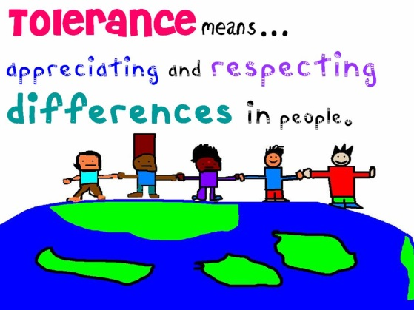
Respectful attitudes:
We want all of our children to have the opportunity to practise listening, learning and thinking about others in a respectful environment. Disagreement and debate are accepted as long as everyone is respectful when exploring diverse fails and world views.
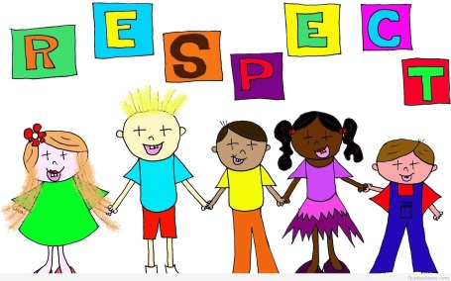
Democracy:
We believe that all of our pupils have the right to be heard and have a voice.
The rule of law:
We want our pupils to have the opportunity to examine different examples of codes for human life, including commandments, rules or precepts offered by different religious communities and be able to compare these with state law. We want our pupils to learn that all people should be equal before the law.
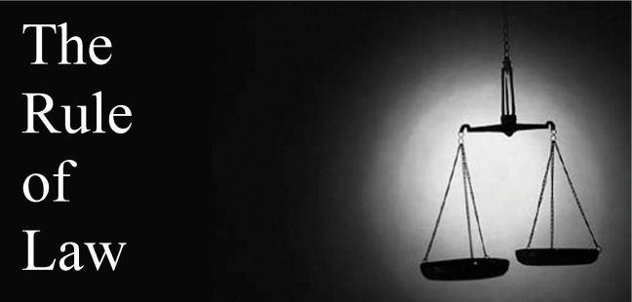
Individual liberty:
We want our pupils to think about themselves as individuals within particular cultural and social contexts and understand how cultural rules and pressures can affect them. We want them to consider the ways in which they have the freedom to make individual choices.
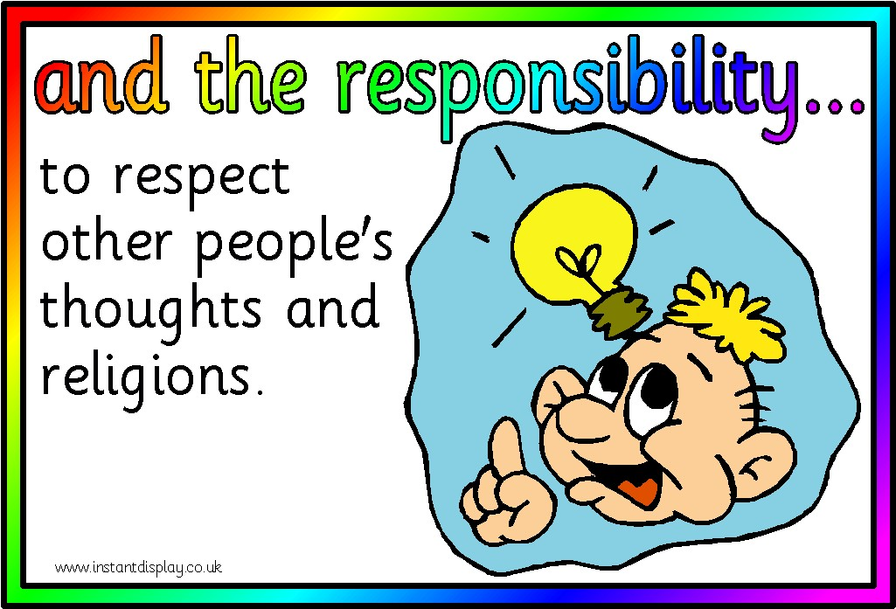

What do we do to promote British Values at Springfield Junior School?
There are many things that we do in school to promote British Values, some explicit but others are less so. Indeed, our whole school ethos is based on values that we believe are fundamental for life.
One of our favourite school words is Respect and we firmly believe that it underpins everything we do in school; respect for each other, respect for ourselves as well as respect for the environment and belongings.
Our other school words are Question, Explore, Give and Succeed and again they are core to what we believe in school and actively promote. We want all of our pupils to have the best life chances possible through good learning opportunities which enable them to make lots of progress so they can enjoy a happy and successful life; regardless of what they choose to do in the future.
Our lessons are wide and varied and aim to equip our pupils for a love of life-long learning. We actively encourage our pupils to ask questions and explore further whilst always maintaining respect for others and their beliefs.
We encourage all children to achieve, regardless of their ability and encourage active participation whilst always being mindful of individual needs.
Through assemblies, PSHE, RE and other curriculum lessons we explore what it means to be world citizens and how to cope with the demands of life but also how to enjoy and celebrate being part of an amazing world.
Our School Council is a democratically elected body with 2 representatives from each class who meet every 2 weeks. They discuss issues relevant to them and make decisions as well as taking a lead in many school activities. They have helped to interview new staff, organised lots of fundraising activities including the annual Children in Need day, looked into new play equipment amongst other things.
Our Eco-council also help to remind us of the importance of caring for the environment and encourage sustainability whilst our gardening club make the school look amazing and grow lots of flowers and vegetables.
Our annual Harvest Festival celebration, nativity play, carol concert and Easter service are when we join up with our local church to enjoy traditional Christian services whilst in school we celebrate Diwali, Hanukah, Chinese New Year and many more.
We also fit in traditional events such as our annual Pancake Day races and Easter Bonnet Parade as well as sports day and inter-house sports competitions.
School trips help us to develop learning in the wider environment and one of our classes has recently developed links with a school in Italy as part of their topic.
Anti-bullying is a major part of our work in school and we actively promote strategies to tackle bullying. We take part in the annual Anti-bullying campaign and have an Anti-bullying committee comprised of a wide range of stakeholders who meet every ½ term.
We encourage outside agencies and visitors to come into school to talk to our pupils including the police, fire service, health officials, NSPCC and local church group as well as organising theatre groups, inspirational authors and the like to come and work with us.
As part of their topics our children have also welcomed local miners, a dentist, a visitor from Action Aid and an archaeologist amongst others and we have held highly successful Careers Week with a whole host of visiting speakers.
After-school clubs help to promote other skills and we are very proud of our annual participation in Young Voices and our school production as well as all of our sporting groups.
Our school behaviour policy and award system are based on a fair and consistent approach in which all pupils are encouraged to take responsibility for their actions. Staff act as positive role models for children and focus on helping our pupils achieve their aims. We expect everyone in school to treat each other as they would wish to be treated themselves.
Assemblies and lessons look at important events in the news and time is used to discuss and tackle issues. Black History Month materials are used widely in October and we also make sure that we help our children to explore historic events such as general elections, the anniversary of the end of WWII, the Olympic Games and the Queen’s reign.
- Training

As part of our statutory duties and through opportunities we will ensure that all staff are fully aware of the threats, risks and vulnerabilities that are linked to extremism and radicalisation. This includes been alert to early indicators, responding to and reporting. This will include all staff including volunteers, governors and will be incorporated into staff induction training.

We will ensure that all staff are trained to be equipped and skilled in this field, making available training resources and support opportunities where required. We will
follow the recommendations of the Local Authority and ensure staff attend Prevent/WRAP, or other recommended training that is relevant to the job role within the school.

In making sure that support needs are met of the pupils that staff including volunteers and governors understand CHANNEL, CHANNEL strategies and how to refer into Channel using local processes.

- Procedures for Referrals

We will treat any worry or concern that a child or young person in the School may be exposed to possible extremism, extremist ideology and or radicalisation as a safeguarding concern.

Recent case studies and from Derbyshire’s own experiences have identified the following Schools have been concerned about and sought advice on:

- Parents/carers presenting worrying views to any Teacher, visitor or Governor;

- A Staff member, governor, volunteer or visitor presenting concerning views;

- Access to radical teachings by anyone in the School;

- Online exposure and the viewing of on line materials seen to be concerning, disturbing, inflammatory, or anti- British in tone;

- Any child or young people/parents/ visitors on school property who you may feel are discussing/providing information to children that may be seen as inciting or inflammatory;

- Taking action to remove children from curriculum based activities or visits on the basis of a view seen to be perceived as linked to an extreme view, ideology or irrational fear, or using health and safety reasons.

All concerns and incidents will be bought to the attention of the Designated Safeguarding Lead, who will follow the agreed procedures, and where needed can also seek advice, from a Child Protection Manager (for Schools/ Education).

The Department of Education has also a dedicated a telephone helpline (020 7340 7264) to enable staff and governors to raise concerns related to extremism. It is not intended for use in emergency situations.

Where a concern or incident is judged to be immediate and serious an appropriate lead in the School will contact the police directly.

All concerns will be referred by the Safeguarding Designated Lead into Children’s Social Care
(Call Derbyshire/ Starting Point), using the online form. In all cases the Risk Indictor Checklist needs to be completed, unless there are immediate safeguarding concerns

There is a case referral pathway process in Derby City and Derbyshire, where depending upon significance, and level of concerns, this may include a referral into the local Prevent Team, who may then go on to make a referral into Channel.

We will as a school display for all staff, an agreed schools response to individual cases, to help assist the Designated Safeguarding Lead in determining an appropriate response.

See Appendix A

- Safeguarding Roles and Responsibilities

All Staff and Volunteers of our School have responsibility for the following:
- Being aware of the Derby City and Derbyshire Safeguarding Procedures, and with reference to Safeguarding Children and Young People Vulnerable to Violent Extremism, ensuring these procedures are followed;
- That Staff including Volunteers are aware of the Derby City and Derbyshire Safeguarding Children Board’s Escalation Policy and Process, which may be followed if a staff member fears their concerns have not been addressed, and of the Confidential Reporting Code (Whistle Blowing);
- That staff take responsibility to undertake training provided and keep up to date;
- Being alert to the definitions and indicators around extremism and radicalisation, acting upon any of these concerns by reporting these to the Designated Safeguarding Lead(s) within the School;
- Bringing any concerns relating to extremism, or worrying ideologies, where a child or young person may have access to materials either online media contact or viewing to the Designated Lead/Teacher(s) for Safeguarding who is the single point of contact for Prevent concerns;
- Bringing any concerns to the Designated Safeguarding Lead relating to parents/carers or visitors on the schools premises relating to views seen to be inflammatory, or contrary to the schools principles in this policy and to a curriculum promoting diversity;
- Being proactive in the school in protecting vulnerable children / young people from exposure to radical views and been radicalised by them;
- Promoting an ethos within the school with regard to principles of equality, diversity, and the positive values of different cultures;

- Understanding the implications of prejudice based bullying in an aim to protect children and young people from being radicalised;

- Understanding British values, in the context of citizenship and being proactive in this contributing to children’s learning and the broader values of living & working in Modern Britain.
- Listening to, and seeking out, the views, wishes & feelings of our pupils, ensuring that the vulnerable child’s voice is heard and acknowledged;
- Obtaining advice and seeking support for our pupils using the referral routes when a child or young person has been identified as vulnerable to extremism and radicalisation.
The Designated Safeguarding Lead has responsibility for the following:
- That they are the single point of contact in relation to protecting pupils/students from radicalisation and involvement in terrorism (SPOC);
- Being aware of the Derby City and Derbyshire Safeguarding Procedures in regard to ‘Safeguarding Children and Young People Vulnerable to Violent Extremism’, ensuring these procedures are followed.
- That all concerns are seen as safeguarding concerns and reported under the procedures which are set out;
- That when concerns are bought to their attention they are aware of the advice and referral process PREVENT/Channel which is available in the local authority;
- That they may be asked to attend a Channel panel to present, discuss and agree a course of action on a child or young person raised through that process;
- That they ensure the child or young person receives the support available through PREVENT and Channel;
- That they are aware of signposting to other support services, web based organisations and agencies that can assist a school;
- They will monitor the effect in practice of the RE/PSHE curriculum and assembly policy, or in teachings where relevant that they are used to promote community cohesion and are reflective of multi-faith and beliefs;
- They inform and keep up to date as part of their training responsibilities all staff and volunteers;
- That they keep records of any concerns labelled clearly as Prevent, use and record risk assessments, interventions, and any advice and support that is sought.

Governors, Proprietors and School Leadership of our school are responsible for (and need to ask a School about):
- That the Designated Lead in the School will act as the single point of contact for concerns;
- Ensuring that all Designated Safeguarding Leads have the appropriate Prevent/WRAP training and receive regular updates through briefings and research and this includes the link Safeguarding Governor;
- That all other staff in contact with pupils/students complete training;
- Ensuring that the Safeguarding Designated Lead(s) is equipped to deal with extremism and radicalisation in their school and he/she remains up to date with any guidance/legislation changes;
- That processes of keeping records are in place for the reporting and recording of any concerns. That there is evidence of Risk Assessments being undertaken, and records are maintained of any interventions, advice and support that have been sought;
- To consider how children may be taught about extremism and radicalisation as part of the broader Safeguarding in the school which is promoted through teaching and learning opportunities as part of providing a broad and balanced curriculum;
- Actively promoting values of democracy, the rule of law, individual liberty, mutual respect and tolerance of those with different faiths and beliefs;
- Having in place an Online Safety Policy which can also address the concerns of radicalisation on line;
- Making sure that this policy including any teachings or statements relating to the work of protecting children/young people from radicalisation is available to parents, and carers as appropriate, including displaying on the schools website.
This school will use the agreed pathway and recommended forms as outlined in this policy, in Appendices B, to help establish a concern, reporting and recording a concern.

- Visitors & Use of the schools Premises

Visitors
- Upon arriving at the School all visitors including contractors will read the Safeguarding and Child Protection Guidance and any relevant Codes of Behaviour which they will be required to adhere to.
- Visitors and contractors will be subject to Identification checks which will include clarification of the purpose of their visit.
- We may undertake further precautions in allowing visitors and contractors on their premises.
- We will refer to our lettings policy, and refer the speaker/contributor to that policy .

School Premises
We will ensure the school building will not be used to give a platform to extremists this will be monitored as follows:

- If a member of staff wishes to invite a speaker into our school, prior approval and agreement will be made with the Head Teacher/Principal which will be subject to the appropriate school safeguarding checks.
- That the school will refer to the ‘Speaker and External Contributors Policy’ issued by Derbyshire safeguarding education service, ensuring that this document is shared with the provider/speaker before the event. Once completed and checked with all parties in agreement the event can then be permitted to take place.
- Usage of school premises will be monitored and in the event of any behaviour not in keeping with this policy or the Safeguarding and Child Protection Policy, the School will terminate the contact and may in some circumstances contact the police.

- Stay Safe- terrorist fire arm attack
This link features Government guidance and a short film called ‘Stay Safe’ about what action to take if a school/any setting is caught up in a terrorist firearms attack. We will inform our staff of such a guidance and familiarize all staff with the Run, Hide, Tell.
https://www.youtube.com/watch?v=4jxOXbpTmnk
The current response for a school is training staff in run, tell and hide and as recommend by the DfE. As a Local Authority we want to ensure all staff have the information needed to help them stay safe.
It’s important all staff:
- are alert but not alarmed
- are vigilant and report suspicious behaviour
- plan ahead what to do to stay safe.
Nationally there are five levels of threat:
- low - an attack is unlikely
- moderate - an attack is possible but not likely
- substantial - an attack is a strong possibility
- severe - an attack is highly likely
- critical - an attack is expected imminently
The Stay Safe principles are: Run, Hide and Tell

Run
- If there is a safe route, run, if not hide.
- Insist others go with you.
- Don’t let them slow you down.
- Leave your belongings behind.

Hide
- If you can’t run, hide.
- Find cover from gunfire.
- Be aware of your exits.
- Try not to get trapped.
- Lock yourself in a room if you can.
- Move away from the door.
- Be very quiet, turn off your phone.
- Barricade yourself in.

Tell
Call 999 - What do the police need to know?
- Dial 999 when you are safe.
- Give your location.
- Give the direction the attacker is moving in.
- Describe the attacker, especially things that cannot be changed such as tattoos, facial hair, ethnicity etc.
- Give any further information.
- Can you safely stop others from entering the area?
- https://www.gov.uk/government/publications/recognising-the-terrorist-threat (opens in a new window)
- Help, Support & Signposting

Child Protection Manager Schools/Educational Settings Derbyshire- Debbie Peacock
01629 531079 Debbie.peacock@derbyshire.gov.uk

Lead officer for Prevent at Derbyshire County Council, 01629 538494 or 07771 980107

Derbyshire Police 101- can route non urgent referrals through to the PREVENT Team
Children’s Social Care (single point of Contact- Starting Point) - 01629 533190

Contact Numbers / referral links*
Call Derbyshire - 01629 533190 (24hr, 7 days a week – sharing concerns re Adults or Children – concerns re children will be triaged via Staring Point)
Starting Point Advice Line - 01629 53 53 53 (Mon – Fri, 8am – 6pm – advice and guidance re concerns about children)
www.derbyshire.gov.uk/startingpoint
*when making a referral you will need to complete the risk indicator checklist this is available on the starting point website and as a document in this policy along with the police prevent referral form ( appendices B)

Police Prevent Team - 0300 122 8694 or 101
Keystone – 101 (in an emergency dial 999)
Police Prevent Lead - 01332 643058

Must Read Documents
https://www.gov.uk/government/publications/prevent-duty-guidance
https://www.gov.uk/government/publications/channel-guidance

Derbyshire Constabulary Prevent Web-page - including Prevent video clip (17 mins)
http://www.derbyshire.police.uk/Safety-advice/Terrorism/Prevent-Team/Prevent-Team.aspx

Prevent E-Learning (for Derbyshire County Council staff and Derbyshire Schools) (contains local contacts and referral routes)
www.saferderbyshire.gov.uk
Training and resources- counter terrorism training- Prevent /WRAP bookings
Channel E-Learning
http://course.ncalt.com/Channel_General_Awareness/01/index.html
Home Office Prevent E-Learning – aimed at schools / education https://www.elearning.prevent.homeoffice.gov.uk

Other useful web-links / documents
http://www.eastmidlandsprevent.co.uk/
https://www.gov.uk/government/publications/counter-terrorism-strategy-contest
https://www.gov.uk/government/publications/prevent-strategy-2011
https://www.gov.uk/government/publications/protecting-children-from-radicalisation-the-prevent-duty
https://www.gov.uk/government/publications/the-use-of-social-media-for-online-radicalisation
www.preventtragedies.co.uk
http://educateagainsthate.com/
http://www.preventforschools.org/

Management of the Policy

The Head Teacher/Principal of Springfield Junior School will implement the policy and will ensure that all staff including volunteers have read and signed confirming that they have read and understood their responsibilities.
The Governing Body/Proprietor will oversee the policy; ensure its implementation and compliance to statutory duties reviewing its content on an annual basis.
We will undertake a regular audit and review of this policy and in light of any changes in guidance /legislation how these changes will be implemented within the School.
The Head Teacher/ Principal will report on and discuss progress within the School/Educational setting to the Governing Body on an annual basis.
A record of the minutes are recorded the School Governing Report covering the discussion on the Policy of Extremism, Radicalisation and the protection of British values, detailing how proactive the school is in ensuring this policy is reflected in the schools ethos and curriculum.

Signed by:

Proprietor/ Chair of Governors Head Teacher/Principal

Date: Date:

Schools Prevent Flowchart & Pathway Appendix A
Concerns over parents/ guardians
Refusal to give consent to visit mosque or other religious establishments

Pupil displays concerning ideology/accesses materials online or attempts to
Worry/concern about the behaviour & actions of one pupil or groups of pupils in the school & or with links to concerning adults/local group
Pupil displays a change in behaviour/appearance
Concerns over parents/ guardians
Playground campaigning, refusal to take part in multicultural events, opposes promotion of other cultures in school

Use the Prevent Risk Indictor Checklist

Use Starting point professionals advice line 01629 535353 8am-6pm / contact Seamus Carroll / Child Protection Manager
Does not require a Prevent referral

Complete a schools child Welfare/CP report form attach to checklist

Attempt a resolution

Write out to all parents, explain purpose to all parents, arrange appointments with the individuals, involve link governor, use school complaints process
Seek help & share & discuss your concerns with the School Designated Safeguarding Lead

This process into Call Derbyshire triggers triage for police prevent team and Channel
Are you still concerned? Is this a Safeguarding /Prevent referral?

No resolution

Could be an ideology and a capability of a terrorist/extremist nature. Pursue a safeguarding referral if concerned for child connected to the parent/guardian
Pursue a safeguarding referral into Call Derbyshire using the on line form, & complete a prevent referral form. If urgent child protection concerns call 01629 533190
Contact DCC Prevent Lead Seamus Carroll on 01629 538494 or Child Protection Manager on 01629 531079

CONTEST is the UK’s counter-terrorism strategy that aims to reduce the risk we face from terrorism so that people can go about their lives freely and with confidence.

It is made up of the four Ps;
- Protect – strengthening our borders, infrastructure, buildings and public spaces from an attack
- Prepare – where an attack cannot be stopped, to reduce its impact by ensuring we can respond effectively
- Pursue – to disrupt or stop terrorist attacks

The fourth P is Prevent which aims to stop people becoming terrorists or supporting terrorism. It has been described as “the only long term solution” to the threat we currently face from terrorism.

Prevent is challenging and different from the other Ps because it operates in a pre-criminal space, before any criminal activity has taken place.
So Prevent is about supporting and protecting those people that might be susceptible to radicalisation, ensuring that individuals are diverted away before any crime is committed. Remember radicalisation is a process, not a one off incident, so look for changes in a person’s behaviour

Channel is a supportive process designed to protect vulnerable individuals. It is about identifying, at an early stage, those who may be at risk and preventing them from being drawn into criminal activity.

The Channel process is similar to the way we safeguard individuals at risk from involvement in drugs, knife and gun crime, gangs or other social issues. Channel uses similar multiagency partnership structures.

The process can apply to any individual who may be vulnerable to being drawn into violent extremism, regardless of faith, ethnicity, background or age. Those in local communities who have concerns about individuals who may be targeted by violent extremists are advised to contact their local authority, the police, or other trusted organisations for advice.

Support is provided on a case by case basis, tailored to an individual’s needs. Each support package is monitored closely and reviewed regularly. Examples of possible support for individuals include one-to-one mentoring, diversionary activities such as sport, and signposting to mainstream services such as education, employment and housing

If you require further training please click here for more information

Seamus Carroll
Senior Community Safety Officer, County Hall Matlock DE4 3AG October 2017

Safeguarding Roles and Responsibilities- Appendix B

The Risk Indicator Checklist & Police Prevent Referral form

PREVENT- RISK INDICATOR CHECKLIST
Version 2- Guidance- January 2016

Under Prevent (Counter Terrorism and Security Act 2015) we are all when in contact with children and adults in our roles required in our functions to:

- Prevent people from been drawn into terrorism
- Know about and Identify early indicators in pupils vulnerable to extremism.
- Assess the risk of pupils being drawn into terrorism and terrorist ideology.
- Develop the confidence to challenge and intervene.
- Build resilience in pupils through advice, support, intervention eg- Channel and through the curriculum
- Keep records and work in partnership with agencies

The risks of being drawn into extremism, exposure to, or intent to carry out acts may vary from area to area, and differ according to their age, local threat and proportionality. Schools may have different experiences and should identity risks within their local context.
Effective engagement with parents/family is also important as they are in a key position to spot signs of radicalisation. You should be sharing your concerns with a parent/carer unless this may place the child/YP at immediate risk. You should be working with parents/carers to help them know about and identify indicators in their children.

Completing the checklist:
All staff should exercise their judgment in raising concerns and in all cases seek advice from a Designated Safeguarding Lead.
A Designated Safeguarding Lead should have also undertaken PREVENT/ WRAP training. The expectation is that the Designated Lead is responsible for completing the checklist.
The Designated Lead completing this checklist should take into account the information from the person raising the concerns, use discussion from others who have interaction with the child or young person and from information from observations, presenting behaviours and interaction seen with other peers, parents/carers/local community.
The checklist should support the Child Protection Welfare/Report Form in all cases where this is seen to be a concern under Prevent. The checklist should be shared if referring into services and where possible with the parent/carer.

Having completed the checklist this should help you decide next steps and thresholds. You should treat a concern under Prevent as any other safeguarding concern.
If you have immediate safeguarding concerns under Prevent you should be contacting Derbyshire Police on 101 and Children’s Services (Starting Point 01629 533190) if under 18 and adult’s services if 18+.
In all other cases you should complete the Child Referral Form to request early help and assessment www.derbyshire.gov.uk/startingpoint . The form will trigger agency enquiries and this may include liaising with the local Police Prevent Team and referral into a multi-agency panel (CHANNEL) depending upon the information gathered and level of risk.
You should complete and submit the Police PREVENT referral Form in all cases and email to; EMSOU-SB-Derbys@Derbyshire.PNN.Police.UK. This team will decide if they have a role, they are required to record all concerns.
You can seek advice in all cases and should do this by contacting either;
Seamus Carroll is the lead officer for Prevent at Derbyshire County Council seamus.carroll@derbyshire.gov.uk Telephone 01629 538494 or 07771 980107

Child Protection Manager Schools/Educational Settings Derbyshire- Debbie Peacock
01629 531079 Debbie.peacock@derbyshire.gov.uk

The Professional Advice and Consultation Line Starting Point 01629 535353

PREVENT-THE RISK INDICATOR CHECKLIST
The risk of radicalisation is the product of a number of factors. There is no definitive list but these are the researched and known about vulnerabilities, critical factors and indicators. All or none may be present in individual cases of concern. Nor does it mean that vulnerable children/YP’s experiencing these factors are automatically at risk of exploitation for the purposes of extremism.
This checklist applies to all age groups and you may have concerns about parents/carers which are impacting on the child/ren in the school or setting shown through their experiences, behaviours and influences.
The checklist will help you and the other agencies decide:
- Whether there is a risk
- What level or risk
- A pathway to support and intervention
- Provide the model for assessment and management
Name of Child/Young Person

DOB

Year Group

Vulnerabilities to Extremism:

 | Yes | No
- Is in adolescence
- Has experience of poverty, disadvantage, discrimination, social exclusion
- Has low self- esteem, a poor or no sense of belonging,
- Has Insecure , absent, conflicted family tensions or absent family relationships
- Has a significant adult or others in the child’s/YP’s life who appears to have extremist view or sympathies
- Demonstrates a lack of affinity, understanding for others
- Is dissociating from peers
- Is socially isolated from peers
- Demonstrates identity conflict and confusion
- Demonstrates distance from cultural/religious heritage and uncomfortable with their place in society
- Has any learning difficulties /communication and or mental health support needs
- Has a simplistic or flawed understanding of region or politics
- Has experienced trauma in their lives, especially associated with war or sectarian conflict
- Experienced migration, been subject to local community tensions, has a sense of grievance triggered by personal experience racism, discrimination, affected by government policy
- Has unmet aspirations, perceptions of injustice, feeling of failure , rejection of civil life
- Experiences of imprisonment, poor resettlement/reintegration, previous involvement in criminal groups

Critical Risk Factors:
High | Yes | No
Travel

- Is there a pattern of regular or extended travel within UK with other evidence to suggest this is for extremist activity
- Unexplained, vague, unauthorised extended breaks/travel outside of the UK to locations associated with extremist activity
- Is there a pattern of travel to locations outside of the UK associated with extremism activity
- The use of any methods to disguise identity, documents or cover to support this
- Connexions with extremist military camps/locations
High | Yes | No
Experiences, Behaviours and influences

- Use of language seen to be inappropriate (e.g. causing distress or alarm and perceived to be prejudiced, inflammatory, or hateful).
- Have international events in areas of conflict and civil unrest had an noticeable impact resulting in a change in behaviour ( note it is common to have an emotional reaction to world events but this has to be seen in context of other factors listed)
- Being in contact with extremist recruiters
- Expression of extreme views and ideology
- Possession of extremist literature.
- Using extremist narratives and a global ideology to explain personal disadvantage
- Advocating violent actions and means, supporting terrorist attacks verbally or in written work
- Seeking to recruit others to an extremist ideology
 | Yes | No
Access to Extremism/Extremist influences

- Changes in faith/ideology.
- Sudden name change linked to a different faith/ideology.
- Significant changes in appearance.
- Secrecy on the internet & access to websites with a social networking element.
- Narrow/limited religious or political view.
- Attendance at certain meetings e.g. rallies and articulating support for groups with links to extremist activity but not illegal/illicit eg fundraising, propaganda distribution, attendance at meetings.
- “Them” and “us” language/rhetoric.
- Justifying the use of violence to solve societal issues.

Name of worker completing the Checklist:

Status of worker:

Date & Time record made :

Date & Time Record Submitted/Actions taken and by whom.

East Midlands
Prevent Referral Form

Restricted (when completed)

Information will be kept secure and confidential and will only be disclosed to those parties who have a legal and legitimate need to know.
Please complete the below details and email this form to:  EMSOU-SB-Derbys@Derbyshire.PNN.Police.UK |  |  | This will be dealt with by individual Police Force Prevent Teams.
Please complete to the best of your knowledge. Leave blank if unknown.
Your details:
Surname |  |  | D.O.B
Forenames |  |  | Relationship to individual
Contact no.
email
Professional role (if applicable)
Address
Individuals details and summary of concerns:
Please include as much detail as possible.

Surname |  |  | D.O.B
Forenames |  |  | Gender
Contact no.
email
Social Media Username
Ethnicity |  | Nationality
 |  | Place of Birth
Address
Languages Spoken |  |  | English spoken?
School or Educational Establishment
Occupation
Occupation Address

Is the person aware of the referral?  Has anyone been consulted about this referral (safeguarding agency etc.)?  If yes please give details | Yes No  Yes No
Additional Info
Summary of Concerns
Framed around Engagement, Intent and Capability

